Traffic Simulating System
Use-Case Specification: add vehicle
Version 2.1

Revision History
Date | Version | Description | Author
05/10/2008 | 1.0 | a main version | Liangda Li
01/01/2009 | 1.1 | Modified version | Liangda Li
11/01/2009 | 2.1 | Modified version | Liangda Li

Table of Contents
1. Use-Case Name 4
1.1 Brief Description 4
2. Flow of Events 4
2.1 Basic Flow 4
2.2 Alternative Flows 5
3. Special Requirements 7
3.1 display equipment to give user a vision of the map and the interface for operating. 7
4. Preconditions 7
4.1 Environment settled 7
5. Postconditions 7
5.1 Vehicle added 7
6. Extension Points 7
6.1 vehicle customize 7
6.2 born point customize 7
6.3 user choose a born point on the map 7

Use-Case Specification: <Use-Case Name>

Use-Case Name
add vehicle

Brief Description
This user case add vehicle to system to complete the traffic simulating process. User can choose different types of vehicle and put it on a given point of the map to start moving. The backstage controller handle the request and perform the operation.

The main actor of this use case is the user. The backstage controller is an actor within the use case.

Flow of Events

Basic Flow
1. user chooses the option named "add vehicle".
2. user input the parameter(such as initial speed, maximum speed, type or bornpoint) for his vehicle for generation.
3. user confirm his/her choose and give a adding vehicle command to the system.
4. the backstage controller receive the command and choose a road linked to given born point randomly from the several map-determited born points.
5. the backstage controller communicate with the vehicle information database and set the paramter of the certain vehicle input by the user.
6. the backstage controller add the vehicle to the system by building a new model of it, add it to the map-related information and modifying the related system parameters(like total vehicle numbers, vehicle numbers on a certain road, the postion of a certain vehicle on a map, etc).
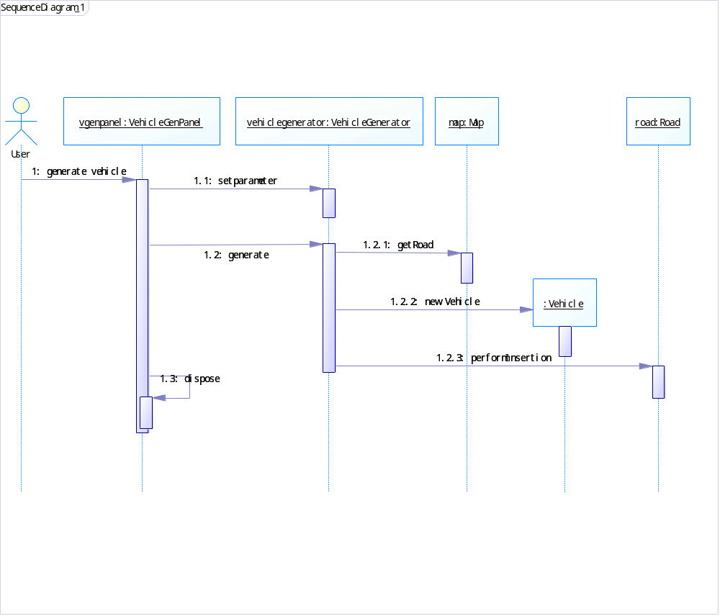

Alternative Flows
*a. the backstage controller adds vehicles when the total vehicles on the map is less than a certain number.
1. system enters backstage controller-authorized mode.
2. the backstage controller add vehicles until the total number of vehicles on the map reached a certain number.
3. the system reverts to user-authorized mode.

*b. at any time, system fails:
1. user restarts the system and reloads the immediate save last time.
2. system reconstructs prior state based on the save.

2a. user customize a vehicle by setting own parameter of it(like speed, size, weight, etc)
1. user chooses the self-decide option.
2. user adjusts the given parameters of a vehicle.
3. user confirms his/her choose and add that as a new type of vehicle to the system.
4. system communicate with the vehicle information database and add the new information into it.

4a. user choose a born point on the map.
1. the backstage ask the user to choose a born point for the vehicle.
2. user choose a certain point on the road of the map as the born point.
3. user confirm his/her choose and send the information to the backstage controller.

5a. system detects the number of certain type of vehicle has exceeded the max number set by the vehicle information database.
1. the backstage controller received the notice that the vehicle can not be added to the map.
2. the backstage controller cancel the adding operation and senda message to notice the user.

6a. system detects the vehicle can not be added to the given point by access the map-related information.
1. the backstage controller received the notice that the vehicle can not be added to the map.
2. the backstage controller cancel the adding operation and senda message to notice the user.
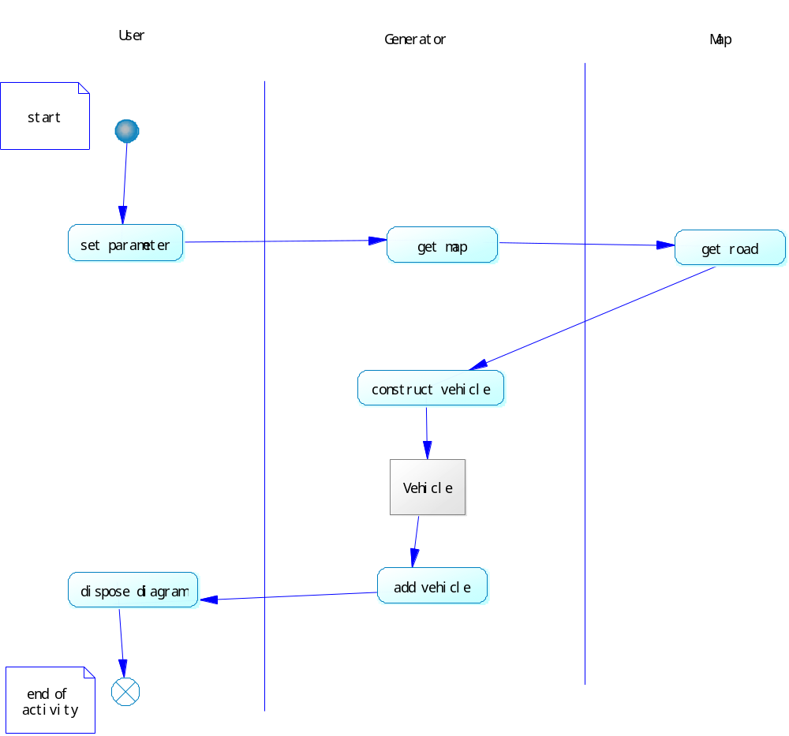

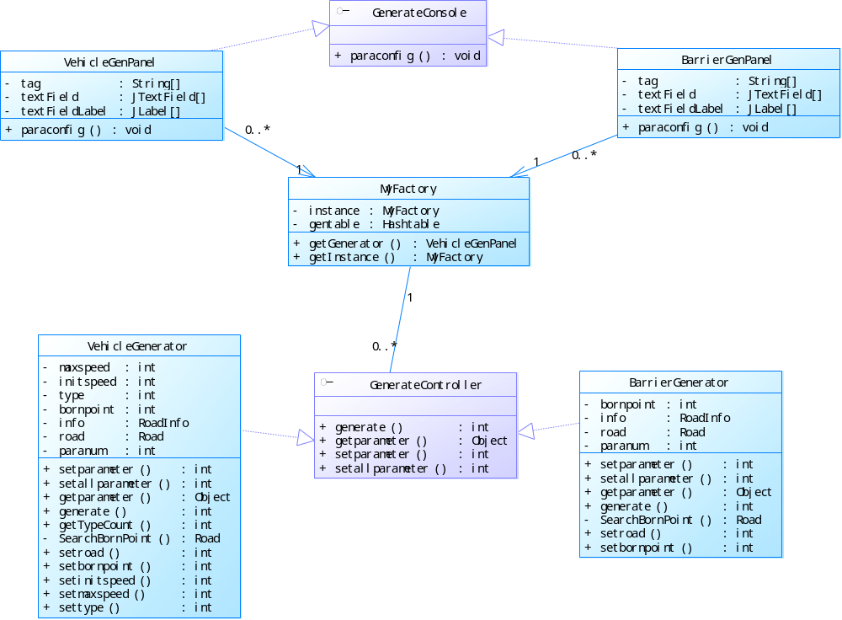

Special Requirements

display equipment to give user a vision of the map and the interface for operating.

Preconditions

Environment settled
the map has been successfully loaded.

Postconditions

Vehicle added
there is a new vehicle on the map starting from appointed position.

Extension Points

vehicle customize
step2: user customize a vehicle by setting own parameter of it.

born point customize

user choose a born point on the map
step4: user choose a born point on the map.

